A+ Computer Science GET NUM X COLORED ACTORS Lab Value - 100

Lab Goal : This lab was designed to teach you how to search a grid and more about the GridWorld case study. You will need a copy of the GridWorld quick reference.

Lab Description : Load a grid randomly using Actor, Bug, Flower, Rock, and Critter. Randomly set each actor to Red, Green, Yellow, Blue, Orange, or Black. Search the grid to determine how many of each color exist and then print out some statistics about the grid.

Sample Data :
See the grid of actors below.

Sample Output :
Files Needed ::
SearchWorld.java
TheRunner.java
GridWorld Project

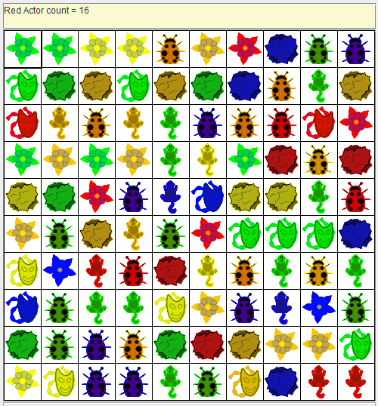

Number of Blue Actors = 19
Number of Red Actors = 18

